

Internal Audit – Continuing Education

Process Understanding Document

Prepared by | Musab Daqa
Date | October 2023

Overview

Khalifa University (KU) Continuing Education Department (CED) was established in 2018 with the dual objectives of offering support to KU faculty and serving the UAE community through the provision of professional development and high-quality training programs designed to enhance skills in the fields of Science, Technology, and Engineering. The CED leverages the expertise of its faculty members to deliver professional development training, offering both short courses and training services to their strategic and external clients. It's worth mentioning that the majority of these clients, mainly the strategic ones, have some connection with KU.

KU experts through CED have a chance to provide professionals with new knowledge, information, skills and opportunities to grow their careers, help advance their organizations, expand their network and impact their fields of profession. CED typically offer a variety of courses cover a wide range of subjects, mainly in the following subjects: Communication Technology & Electronics, Material Development and Manufacturing, Medical, Artificial Intelligence, Energy (Oil & Gas), Cyber security, Advanced technology & security, Specialized Courses.
Continuing education and professional development courses are designed by faculty who are experts in their fields to provide professionals with new knowledge, information, skills and opportunities to grow their careers, help advance their organizations, expand their network and impact their fields of profession. Participants are immersed in high quality learning opportunities and experiences that are both cutting-edge and practical. Instructors are often experienced professionals or subject matter experts in their respective fields. They bring practical knowledge and real-world experience to the classroom.
CED often engage with the local community, offering outreach programs, workshops, and events. These efforts can strengthen the university's ties with the region and contribute to workforce development. Continuous assessment and feedback mechanisms help ensure the quality and effectiveness of programs. Student evaluations and assessments may be used to make improvements.
Previously, the CED operated as an independent/standalone department and had two position, Continuing Education Manager and Continuing Education Specialist. In 2023, there was an update to the Organizational Structure, which resulted in the integration of the CED into the Center for Teaching and Learning (CTL). As a result, the CED now consists of a single position, which is Continuing Education Manager.

Governance

Key Performance Indicators (KPIs)

Key Performance Indicators (KPIs) are essential for measuring the effectiveness of the CED within KU. These KPIs help assess performance, track progress toward goals, and make data-driven decisions to improve strategies.

We have obtained the KU Annual Plan data reported to the Abu Dhabi Executive Office (ADEO) for the fiscal years 2022 and 2023 and this data represent the KPIs. This data pertains to Continuing Education which they considered as a component of the fund diversification project. The data report included four milestones.

The KPIs are comprehensive, as they encompass the strategic cycle of the Continuing Education function by including the following milestones:
1. Update the training schemes of the continuing Education center
2. Increase numbers of fee paying students .
3. Secure more grants and funds from research projects.
4. Establish partnership with wider range of national and international entities for consultation support.

Delegation of Authority (DOA)

The Delegation of Authority (DOA) matrix would list the individuals or positions that have decision-making authorities, and other responsibilities within the department. Some authorities and responsibilities within the CED are contained in the KU approved DoA matrix, mainly it contains the authorities related to the contracting for providing Continuing Education services.

Organizational Structure

An organization structure, often referred to as an organizational chart, is a framework that defines how KU arranges its various roles, responsibilities, and functions to achieve its goals and objectives efficiently. It outlines the hierarchy, reporting relationships, and the flow of communication and authority within the organization. Based on our comprehension, there was an Organizational Structure where the CED operates as a standalone department till FY 2022.
Recently, in FY 2023 a new Organizational Structure is approved and it places the CED department under the CTL Department as outlined below:

- Details about the previous Organizational Structure where the CED operates as a standalone department:
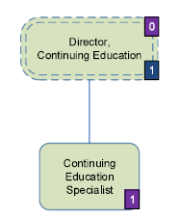
In the previous Organizational Structure, wherein the CED functioned as an independent/standalone department, there were two positions, Continuing Education Director and Continuing Education Specialist. Neither of these positions had been filled, and during this period, the CTL Director was supervising the CED responsibilities with a team that did not align with the designated structure.

- New Organizational Structure positioning the CED department under the CTL Department:
In 2023, a new/ revised Organizational Structure was approved, positioning the CED department under the CTL Department as illustrated below:
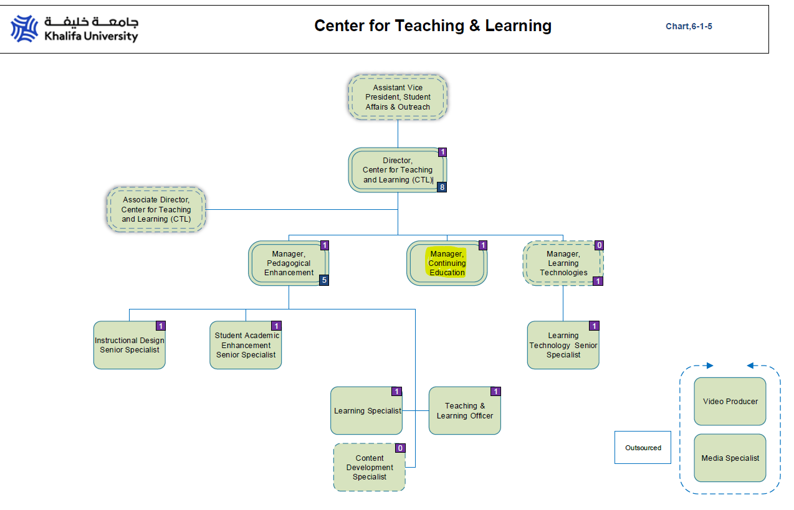
Positions as per org chart | Occupied | Outsourced | Vacant
Continuing Education Manager | 0 | 0 | 1
The role of the Continuing Education Manager, shown as a separate position (1 FTE) on the chart, was just included in the CTL structure. It is currently unoccupied, and since the Continuing Education chart is undergoing restructuring (with its future location on the chart not yet confirmed), there is no available job description for this position.

In light of the revised organizational structure, the CTL now oversees Continuing Education with one position, Manager of Continuing Education. However, at present, there are no Manager of Continuing Education serving in this role, and the management of CED falls under the supervision of the CTL Director. Furthermore, there are no employees who report to the Manager of the Continuing Education. The team currently responsible for managing and executing CED operations and day-to-day tasks is structured as follows:
- Dr. Asli Hassan: Director of the Center for Teaching and Learning (CTL) and she is serving as the Acting Continuing Education Manager.
- Airen Fajardo: A staff member seconded from the Emirates College for Advanced Education (ECAE). Airen is responsible for a wide range of tasks related to course management, registrations, logistics, and all administrative work within CED.
- Ahmed Al Rashid: He is from the Finance Department, and he holds the role of Business Development Senior Specialist within CED. He actively participates in handling proposals and marketing activities for the center.
- Hisham Salim: Also from the Finance department, Hisham has assumed the role of Business Development Manager within CED, with a specific focus on overseeing the financial aspects of the center.

Summary initial observations:
- The The current organizational structure lacks completeness, resulting in the CED having a standalone position (Continuing Education Manager) without any team reporting to this role. It does not include several crucial positions that should be part of Continuing Education, such as the Business Development Manager, Business Development Specialist, Marketing and Media Specialist, Program Coordinators, among others.
- The current organizational structure differs from the actual positions within the CED. The current structure consists of only the Continuing Education Manager under CTL, whereas the roles actively functioning in the CED include the CTL Director acting as a Continuing Education Manager, a staff member seconded from ECAE for administrative work, a Business Development Senior Manager and a Business Development Senior Specialist from finance as these positions are crucial as the CED generates revenue for KU.

Job Descriptions

According to the old/previous Organizational Structure, wherein the CED functioned as department, there were two positions in the CED: the Continuing Education Director & the Continuing Education Specialist, and both positions had job descriptions. Neither of these positions had been filled, and during this period, the CTL Director was supervising the CED responsibilities with a team from different departments.

In 2023, a new Organizational Structure was approved, positioning the CED department under the CTL Department with one position, Manager of Continuing Education. The job description for the Manager of Continuing Education has been prepared by the CTL Director and sent to Dr. Walid for his review. As per HR response, this position is unoccupied, and there is no job description for this role due to the ongoing restructuring of the continuing education.

Summary initial observations:
- There is no approved job description available for the role of Manager of Continuing Education.

Policies & Procedures

The last update to the "Khalifa University Continuing Education Policy and Procedures (P&PS)" occurred in 2021. Here, we will provide a summary of key points outlined in the CED P&Ps document, which are as follows:
- Policies:

- Objectives: The policy offers a clear guide for developing, establishing, and implementing Continuing Education services that align with KU's objectives. It also provides guidance to faculty and staff on how to undertake consultancy/training services. Furthermore, it encourages faculty involvement in community service and expanding their professional networks, all while ensuring that requests for training services comply with the policy's requirements, including the allocated time.

- Scope: Continuing Education at KU is a non-academic, non-degree educational and training program designed to enhance the skills of both recent graduates and experienced professionals in various fields of science and engineering. The program's duration can range from one-day workshops to several weeks, depending on the program's nature and the client's technical needs. Typically, the programs are conducted at KU, but they can also be held at the client's location or other agreed-upon venues. Participants in these programs receive certificates of attendance upon completion.

- Team Structure: As per the P&PS document, KU continuing education activities are coordinated in association with following two positions, Continuing Education Director (reports directly to the President) & Continuing Education Business Development Manager. However, the this team structuer is not matching with the Organization Structuer.

Summary initial observations:
- It's important to note that as outlined in the CED P&Ps document, the coordination of Continuing Education activities include essential roles: a Continuing Education Director and a Continuing Education Business Development Manager. However, in light of the new/revised organizational structure, Continuing Education falls under the CTL with the role of Manager of Continuing Education only. It's worth mentioning that even in the previous Organizational Structure, there was no specific position for Continuing Education Business Development Manager; instead, there was a role known as Continuing Education Specialist.

- Key Highlights of the Continuing Education Policy
- All of the CED activities must go through the approval process.
- Occasionally, external clients may approach KU faculty members to provide training or to utilize KU facilities for training purposes. In such instances, faculty members should direct these clients to the CED for further discussions. CED will then handle the agreement with the client(s). Faculty members should refrain from engaging in contract negotiations with clients for the use of facilities nor for the training fees.
- The regulations for time allocation for faculty and staff engaging in continuing education activities are as follows
- Faculty members can engage in continuing education activities for up to 36 days annually, including consultations, conferences, and delivering continuing education training services. If CED needs faculty involvement exceeding 36 days, prior approval from the Continuing Education Director is necessary to proceed with the program.
- Faculty members should not be involved in a single continuing education activity that lasts for more than two weeks. While some courses may extend beyond this duration, responsibilities should be shared among faculty members to ensure that no individual faculty member is continuously engaged for more than two weeks.
- Faculty members receive an additional payment, separate from their monthly salary, for services like Content Development with Delivery (Teaching). This compensation amounts to AED 2,350 per day (8 hours) and is subject to periodic evaluation based on market conditions.
- Content developers who create course materials, either in hard or soft copy, for clients are compensated at a rate of USD 50 per hour of material/content preparation.
- For courses requiring trainee assessment/test, extra compensation is considered based on client requests.
- Prices for continuing education services may need adjustments due to market fluctuations, and contract negotiations with clients may require flexibility. Specific authorities have the ability to review and potentially increase or discount prices as needed to adapt to changing business conditions.
- The negotiation of training service costs to determine the course rate/ price will involve discussions between CED Team and the Continuing Education Director. When estimating the service cost, factors to consider should include faculty time, course preparation, a 30% overhead, and any other associated service expenses.

- Procedures:

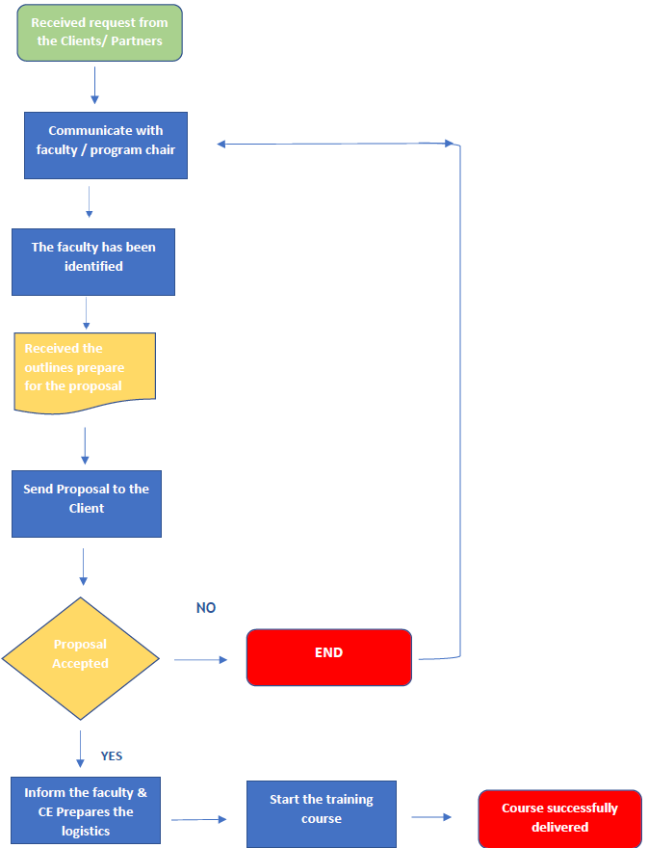
The training course requests follow the subsequent process in accordance with the procedures document:

In practice, and to summarize what has been discussed during our meeting with the process owner regarding the department process, it was mentioned that the process start with a client makes a specific training request, the CED initiates communication by sending an email to the Chairs of various departments and Deans. These department heads and academic leaders assist in identifying the right expert for the requested training. During this phase, faculty members also assess the client's needs, and if they express interest, they must agree to participate in the continuing education project.

Typically, the Chair, Dean, and the Provost review and approve the project. Subsequently, the faculty members develop the content based on the client's demands and prepare the necessary materials. In cases where either the faculty or the client is new and has not worked with the CED before, a meeting is scheduled with the faculty to ensure quality (quality check) and alignment with expectations.

After that they share the proposal with the client, if the clien agree then they offer the courses or the training, and the CED keeps attendance and make sure that the facilities are available and then the training is run. Once the training is completed they give the attendees certificates of completion and then compensate the professor/faculty.

In order to process the payement for the faculty, there are two forms need to be approved by the authorized parties. The two forms are, A1 form (Request to engage in Continuing Education activities) and A6 form (Request to pay the Instructor for his service at CE).

Summary initial observations:
- The P&Ps document does not specify when the next revision/update is scheduled, and it was last issued a considerable time ago in FY 2021.
- The P&Ps concerning the composition of the Organization Structure of CED paragraph do not align with the current Organization Structure details mentioned above. (details above)
- According to the Delegation of Authority (DOA) matrix, policies and amendments require endorsement/review by the General Counsel President and approval by EXCOM. Procedures related to policies must undergo endorsement/review by the Policy Owner EVP and gain approval from the President. However, that the CED's Policy & Procedures document did not receive approval. It's worth mentioning that CED team indicated that the Policy has received approval, but the Procedures have not been approved yet.

Subcontracting and Partnerships

- Subcontracting agreement with the Emirates College for Advanced Education (ECAE):
CED has entered into a subcontracting arrangement/agreement with ECAE for administrative tasks, specifically related to the Learning Management System (LMS) “Massari”. The ECAE integrated Massari to be utilized by CED at KU which allows communication between Learners, Assessors, Internal Quality Assurers and System Administrators. Users can generate plans and reports, record learning progress and maintain ongoing achievements records.

Subcontracting for this software / utilizing service from ECAE allowed CED to move from manual registrations, publications, certifications etc. to an automated system. Automation can assist in clients looking for trainings to visit KU’s website, find a suitable course and register online. Online registration was not available previously. Once registered, it would immediately go through the Massari software. A Massari account will be created, then the client can make the payment for the course and subsequently will have access to course material and relevant training. After the course is completed, attendees can get an electronic certification. This certification will remain in their account in Masary.

The Masary therefore is not only a learning management system but also a trainee information system, where their training certificates are retained and can be accessed trainees for viewing and printing purposes at any time. The agreement/contract with ECAE valid until December 31, 2023.

Despite these advantages offered by Massari, the CED has chosen not to actively utilize it. This decision is based on the belief that Massari requires in-depth data and information, which are considered more appropriate for certification purposes rather than for the training courses provided by CED.

The CED is using a staff member seconded from the ECAE to handle administrative tasks, with her salary paid by the ECAE. KU is invoiced at the contracted daily rate.

Summary initial observations:
- CED does not actively utilize the LMS (Massari). This decision is grounded in the belief that the LMS necessitates extensive details and information, which are deemed more suitable for certification purposes rather than for training courses offered by CED.

- Other partnership with other strategic partners / clients listed below:

S.N | Agreement / Contract No | Client | Date | Amount
1 | MDC/2741866_2 | Mubadala | Aug-22 | AED 157,000
2 | 101001348 | ADNOC | Sep-22 | AED 15,000
3 | 101001385 | Abu Dhabi Police | 22-Oct-23 | AED 63,000
4 | 101001456 | Abu Dhabi Police | 23-Nov-22 | AED 63,000
5 | HR/PROC/MAJ/0150/22 | ADIA | 23-May-22 | USD 16,120
6 | HR/PROC/MAJ/0151/22 | ADIA | 23-May-22 | USD 18,700
7 | KU- SEHA Agreement | SEHA | 15-Mar-19 | AED 3,330,000
8 | NCEMA-SSD/2021/874 | NCEMA | 20-Sep-21 | AED 65,550

Budget vs Actuals

Creating a budget for the CED is a crucial part of financial planning. The budget should align with the department's goals and objectives, taking into account various expenses required to execute Continuing Education strategy effectively. Reporting actual versus budgeted amounts with variances is a critical financial management practice that helps CED to monitor their performance, identify discrepancies, and make informed decisions. Below is the budget Vs. actual and variances of the past 2 years:

Note: In 2022, there existed a distinct cost center with the number of 8471010 for CED, as we can see below. In 2023, the CED merged with CTL, and as a result, its cost center was integrated with CTL's.

- Comparison of actual amounts for FY 2022 with the budgeted figures:

Cost Center | Cost Center Description | Account Description | Budget 2022 | Actual 2022 | Variance
8471010 | KUST - CED | Advertising Services (General) | 107,500 | 105,000 | 2,500
8471010 | KUST - CED | Conferences, seminars and exhibitions and other events: - Local Events | 37,700 | 5,877 | 31,823
8471010 | KUST - CED | Conferences, seminars and exhibitions and other events: - Overseas event | 6,000 | 0 | 6,000
8471010 | KUST - CED | Education-Outsourced training service | 96,120 | 88,576 | 7,544
8471010 | KUST - CED | Entertainment and hospitality | 22,891 | 16,590 | 6,301
8471010 | KUST - CED | Printing supplies | 7,625 | 7,082 | 543
8471010 | KUST - CED | Stationery | 5,625 | 0 | 5,625
Total |  |  | 283,461 | 223,124 | 60,337

- Comparison of actual amounts for FY 2023 with the budgeted figures:

Cost Center | Cost Center Description | Account Description | Budget 2023 | Actual 2023 | Variance
8471280 | KUST - CTL | Advertising Services (General) | 110,000 | 0 | 110,000
8471280 | KUST - CTL | Conferences, seminars and exhibitions and other events: - Local Events | 180,637 | 111,566 | 69,071
8471280 | KUST - CTL | Conferences, seminars and exhibitions and other events: - Overseas event | 128,417 | 23,267 | 105,150
8471280 | KUST - CTL | Higher education and specialisation incentives | 112,500 | 0 | 112,500
8471280 | KUST - CTL | Education-Outsourced training service | 664,480 | 247,298 | 417,183
8471280 | KUST - CTL | Student activities & field trip expenses | 13,140 | 5,131 | 8,009
8471280 | KUST - CTL | Academic Missions - Combined expenses | 0 | 0 | 0
8471280 | KUST - CTL | Entertainment and hospitality | 535,844 | 137,727 | 398,117
8471280 | KUST - CTL | Computer software licenses-Software License Renewal | 312,200 | 291,089 | 21,111
8471280 | KUST - CTL | Subscriptions and membership fees: Trade organisations | 5,000 | 1,775 | 3,225
8471280 | KUST - CTL | Events - Awards, prizes & gifts | 40,000 | 37,250 | 2,750
8471280 | KUST - CTL | Text books and library books | 5,539,833 | 2 | 5,539,831
8471280 | KUST - CTL | School consumables, not specifically mentioned elsewhere | 763 | 0 | 763
8471280 | KUST - CTL | Printing supplies | 154,200 | 12,700 | 141,500
Total |  |  | 7,797,014 | 867,804.84 | 6,929,209

*Source: Budgeting and Reporting – Finance Department. We have requested the CED standalone budget for 2023.

Payments

As per the CED P&Ps document, faculty members receive an additional payment, separate from their monthly salary, for services like Content Development with Delivery (Teaching). This compensation amount is subject to periodic evaluation based on market conditions. For courses requiring trainee assessment/test, extra compensation is considered based on client requests. Content developers who create course materials, either in hard or soft copy, for clients are compensated for the material/content preparation.

Faculty Compensation Pay Rate:
In 2022, a Pay Rate structure has been developed by the Business Development Manager and received approval from the Senior Vice President of Support Services. This Pay Rate structure is a pivotal element of the continuing education 2022 strategy, aimed at establishing consistency in faculty compensation, in accordance with KU's overarching direction. Compensation structures play a vital role in effective compensation management, ensuring that pay rates remain both competitive and equitable. The structures outlined below offer flexibility and serve as an incentive for faculty members to offer more advanced courses.

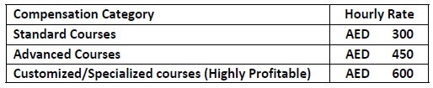
Faculty Compensation Pay Rate

The rates will be reviewed periodically and updated based on the current market conditions and KU interest. Any additional pay rate should be within the provided authority.

Revenue

The revenue generated by the CED goes to KU and its giving back to the government and is not shows in CED budget. In 2022, a revenue of AED AED 4,664,125.27 was generated from Continuing Education activities. The details are as follows:

- SEHA Clinical Research Program, AED 3,886,100
- ADIA Summer Bridge Program Math & Python, AED 134,270.27
- ADNOC Ro' ya Program, AED 292,530
- Mubadala Summer Boot Camp, AED 164,850.00
- Advanced Electronics ( AD Police) 2 Sessions, AED 132,300
- Artificial Intelligence for Emergencies and Crises ( NCEMA), AED 54,075

Costing Basis for the Courses / Trainings / Pricing Schedule

As per the CED P&Ps document, the negotiation of training service costs to determine the course rate/ price involve discussion between the CED team members. When estimating the service cost, factors to consider should include faculty time, course preparation, a 30% overhead, and any other associated service expenses. Costing variables are (where applicable): Faculty Compensation, Course Preparation, Overhead 30%, Laboratory, Training Venue, Materials Production (Printing), Training Supplies, Catering Services, IT Services, Assessment, Grading, and Others.

Training Course Cost and Prices:
In 2022, as part of Continuing Education strategy is to standardize training course rates to align with KU’s direction. The table below shows the cost incurred and prices prepared based on the standard continuing education calculator. The below rates will be served as department’s standard training course rates guidelines effective in January 2022.

Pricing Structure
1. Face to Face training actual cost with 30% overhead.
2. Online Training with 20% discounted rate from the face to face course cost.
3. Group / corporate as per the management approval.

The details of the prices are mentioned in the “Training Course Cost and Prices 2022” document. Thes rates will be reviewed periodically and updated based on the current market conditions and KU interest, any discount over / below rate should be within the provided authority.

Committees Involved In The CED

There are no committees established for the Continuing Education Department.

Courses Planning And Marketing Studies

An annual course plan is created at the beginning of each year. Furthermore, there is an annual process for reviewing and enhancing the courses and training programs. This process involves incorporating updates into existing courses and introducing new ones, among other improvements. Additionally, the training brochure is made available on the KU website, and the detailed course plan is uploaded for reference.
CED team mentioned that they do not conduct formal market studies. Instead, they rely on faculty feedback and trends to identify high-demand courses. Furthermore, a significant portion of CED's clients are government organizations who choose to engage with CED, rather than seeking private or foreign companies. The CED team believes there's no need to actively seek additional clients, as they are fully utilizing their faculty and their current clients are satisfied, also they don’t have resources.

Moreover, CED collaborate with the Marketing & Communication Department to run a marketing campaign where they promote all of KU's courses, including their continuing education offerings, to raise awareness in the community. This campaign helps generate leads and identifies individuals who may be interested in the courses once it is launched, as it primarily runs on social media platforms. Additionally, as part of their strategy for expansion and exploring new markets, CED is actively reaching out to its alumni network to promote participation in continuing education courses and training programs. It was also noted that individuals seldom register for courses through the website as mostly their reluctance to make electronic payments with their cards and other reasons. Additionally, they prefer not to personally cover the course fees but rather have their companies sponsor the expenses.

Feedback / Satisfaction Surveys

The survey process conducted after CED courses is a structured and systematic approach designed to gather valuable feedback from participants. This feedback is essential for assessing the quality of our programs, making data-driven improvements, and ensuring that CED meet the evolving needs of the learners. Also, obtaining feedback from participants is an integral part of the ongoing improvement process within the CED.

Following each training course, the CED conducts a post-course survey, and the team has provided us with two illustrative instances—one from 2022 and the other from 2023. The survey template encompasses various facets of the training experience. It inquires about participants' satisfaction with aspects such as course alignment with expectations, training content, instructor performance, availability of resources and visual aids, overall rating of the knowledge and utilization of facilities, and the quality of administrative support.

An illustration of the satisfaction survey summary conducted in 2022, as documented in the CED annual report, reveals an impressive overall satisfaction rate of 94%.

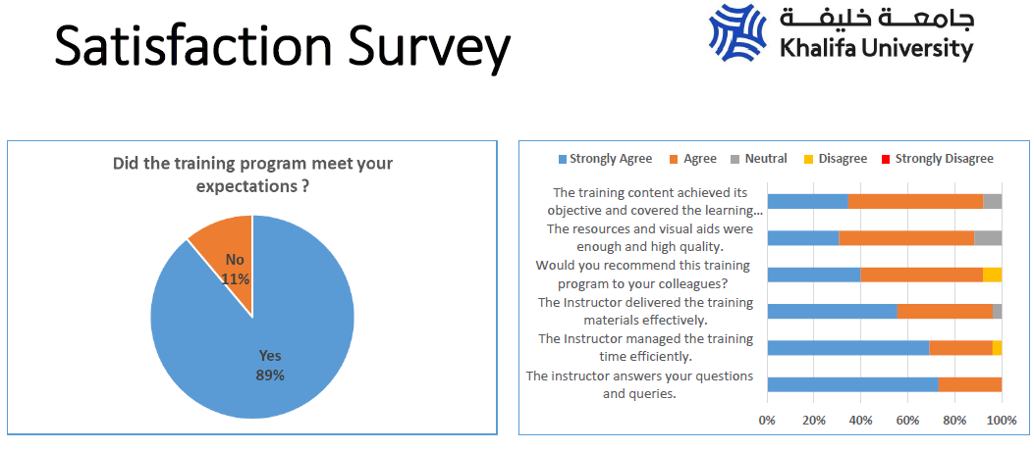
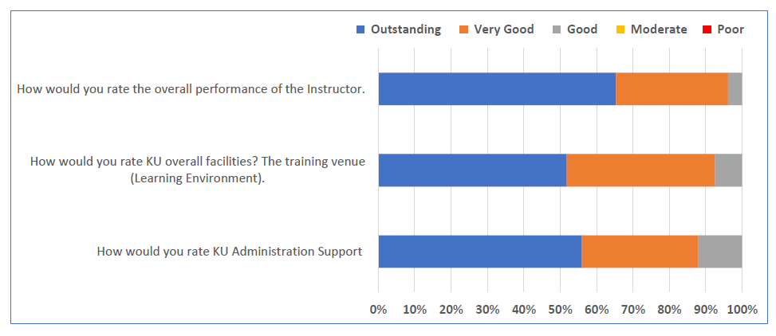

Reporting

The only required report from the CED is the annual report. CED has prepared the “Continuing Education Annual Report – FY 2022” and we have received a copy of the report, which includes the following topics:

- Key Partners
- Training Courses Status
- Process
- Training Courses/Workshops List
- Free of Charge Workshop
- Revenue
- Satisfaction Survey
- Current Projects
- Summary & Recommendations

Registrant Statistics & Number of Courses Offered in 2022

As indicated in the Continuing Education Annual Report for the year 2022, a total of 446 individuals actively participated in a variety of training programs throughout the year. Additionally, the report highlights the successful completion of 14 trainings and workshops, with a notable issuance of 115 certificates.

Accreditations / Certifications

Accreditations are not applicable in this context, as the Continuing Education Department exclusively offers short-term courses and training programs that do not require accreditation from external bodies.

Training Course Calendar

The training course calendar is available on the KU website, which provides information about the course name, dates, specifics, and fees.

Initiatives

As discussed with the CED, it was mentioned that faculty members are often occupied with their busy schedules and have a limited number of hours available to work with the CED, typically 36 hours per year. Sometimes, this allocation of time isn't sufficient to meet the demand for courses and training offered by the CED. In response to this challenge, we inquired about any departmental initiatives to create recorded training courses that clients can access online through a username and password for a specific duration, as an alternative to live courses. This approach could result in significant cost savings and can offer more courses during the year. In this context, the CTL director mentioned that there were no such initiatives in 2022, but she has recently initiated such project called TDM using the Blackboard platform, which is currently in the testing phase.

Blackboard is a commonly used learning management system (LMS) that many educational institutions utilize for offering online courses and managing course content, assignments, discussions, and more in a virtual environment. It provides a platform for instructors to create, deliver, and assess online courses and for students to access course materials and participate in online learning activities.

Challenges

- It's It's crucial to highlight that they are facing a substantial challenge, primarily linked to the availability of appropriate designated spaces for their continuing education activities. Especially the space they are using in Habshan they can utilize but they need to have it for them as a priority.
- Another challenge they are facing is the vacant position of the Manager of Continuing Education, which currently falls under the responsibility of the CTL. They have initiated collaboration with the IT team to automate the forms instead of relying on manual processes.
- The current Delegation of Authority (DoA) is not comprehensive. For instance, the approval process for certain forms is not clearly defined, as the relevant parties are not mentioned in the DoA. Therefore, they require updates to the DoA to encompass all aspects of Continuing Education (CED) activities and operations, particularly for regular operations, as the current DoA only covers authorities related to CED contracts.
- They are experiencing procurement process delays resulting from the essential adherence to procurement procedures and the client take time to provide wit hthe requirements. This situation is significantly affect their available opportunities.

Benchmarking

Benchmarking helps KU identify areas where they can improve their performance and efficiency. By comparing their processes, practices, and outcomes with those of industry leaders or competitors, organizations can set performance targets and work towards achieving them. It allows KU to streamline their processes and operations by adopting best practices identified during the benchmarking process. This can lead to cost reduction, increased productivity, and higher quality outcomes.

- Benchmarking the Continuous Education Department at Khalifa University with MIT (Massachusetts Institute of Technology). This involves a thorough analysis of various aspects of both universities. Here's a summary of benchmark results:

- Program Offerings:
- Khalifa University offers a diverse range of continuous education programs, including certificates, courses, and degree programs, primarily focused on Science, technology, engineering, and mathematics (STEM) fields.
- MIT offers an equally diverse set of continuous education programs, emphasizing its strengths in technology, engineering, business, and other fields.
- Faculty Qualifications:
- Khalifa University employs highly qualified instructors, often with advanced degrees and relevant industry experience.
- MIT boasts world-renowned faculty members, many of whom are experts in their respective fields and have made significant contributions to research and innovation.

- Curriculum and Course Content:
- Both institutions offer high-quality curricula with a focus on practical applications and real-world relevance.
- MIT's courses often incorporate cutting-edge research and technology into their content, setting a benchmark for innovation.

- Student Enrollment and Demographics:
- Khalifa University attracts a diverse group of students, including working professionals and international learners, enhancing its regional and global reach.
- MIT has a global reputation, attracting a highly competitive and diverse pool of students, often including leaders in various industries.

- Quality of Instruction:
- Khalifa University emphasizes interactive and engaging teaching methods, leading to positive student feedback and strong course completion rates.
- MIT is known for its rigorous and challenging courses, leading to a high level of student engagement and academic excellence.

- Student Support Services:
- Khalifa University provides comprehensive student support services, including academic advising, career counseling, and technical support.
- MIT offers a wide array of support services, leveraging its extensive resources to ensure student success.

- Admission Criteria and Requirements:
- Khalifa University offers flexible admission requirements, accommodating both seasoned professionals and individuals seeking career advancement.
- MIT has highly competitive admission criteria, attracting top-tier talent from around the world.

- Marketing and Outreach:
- Both institutions employ effective marketing strategies to promote their continuous education programs, leveraging online presence and promotional materials.
- MIT's brand recognition and reputation are global, providing a distinct advantage in marketing efforts.

- Financial Models and Tuition Fees:
- Khalifa University offers competitive tuition fees and explores scholarship and financial aid options to make education accessible.
- MIT's financial model includes a combination of tuition revenue, research funding, and philanthropic support.

- Technology and Online Learning:
- Both institutions invest in state-of-the-art technology infrastructure and online learning platforms to facilitate remote and blended learning.
- MIT's online resources and tools often incorporate cutting-edge technologies and interactive features.

- Industry Partnerships and Employer Engagement:
- Khalifa University collaborates with regional industry partners and employers, offering internship opportunities and industry-driven curriculum development.
- MIT has a strong history of industry partnerships, leading to extensive opportunities for students to engage with top companies.

- Student Outcomes and Career Success:
- Khalifa University's continuous education programs contribute to graduates' career advancement, with positive outcomes in terms of job placement and salary increases.
- MIT's strong reputation and global network result in excellent career prospects for its graduates.

- Research and Innovation:
- Both institutions actively contribute to research and innovation, with Khalifa University focusing on regional challenges and MIT on global issues.

- Regulatory Compliance and Accreditation:
- Both institutions maintain compliance with relevant regulations and accreditation standards for continuous education programs.

- Continuous Improvement Initiatives:
- Both institutions have established processes for continuous improvement, aligning with their strategic goals.

- Global Reach and Alumni Network:
- Khalifa University is expanding its global reach, and its alumni network is growing and making significant contributions in the MENA region.
- MIT's global reach and influential alumni network are extensive, leading to significant impact on a global scale.

- Key Success Factors:
- Key success factors include program relevance, faculty quality, student support, and strong industry partnerships for both institutions.

- Lessons Learned and Recommendations:
- Khalifa University can learn from MIT's emphasis on cutting-edge research and innovation in curriculum development.
- Collaboration with industry and employer engagement should continue to be a priority for Khalifa University to enhance program relevance.

- Benchmarking the Continuous Education Department at Khalifa University with Georgia Institute of Technology. This involves a thorough analysis of various aspects of both universities. Here's a summary of benchmark results:

- Program Offerings:
- Khalifa University offers a diverse range of continuous education programs, primarily focusing on STEM fields and regional industry needs.
- Georgia Tech, known for its strong engineering and technology programs, offers a wide variety of continuous education options, including degrees and professional development courses.

- Faculty Qualifications:
- Khalifa University employs qualified instructors with advanced degrees and relevant industry experience.
- Georgia Tech boasts a world-renowned faculty, many of whom are experts in their fields and contribute to cutting-edge research.

- Curriculum and Course Content:
- Both institutions offer high-quality curricula with a focus on practical applications and industry relevance.
- Georgia Tech integrates industry trends and emerging technologies into its course content, setting high standards for innovation.

- Student Enrollment and Demographics:
- Khalifa University attracts a diverse group of students, including working professionals and international learners, enhancing its regional and global reach.
- Georgia Tech's continuous education programs draw students from across the United States and around the world, reflecting its global reputation.

- Quality of Instruction:
- Khalifa University emphasizes interactive and engaging teaching methods, leading to positive student feedback and strong course completion rates.
- Georgia Tech is known for its rigorous and challenging courses, fostering a culture of academic excellence and research-driven instruction.

- Student Support Services:
- Khalifa University provides comprehensive student support services, including academic advising, career counseling, and technical support.
- Georgia Tech offers a wide array of support services, leveraging its extensive resources to ensure student success.

- Admission Criteria and Requirements:
- Khalifa University offers flexible admission requirements to accommodate both seasoned professionals and individuals seeking career advancement.
- Georgia Tech has competitive admission criteria, attracting top-tier talent nationally and internationally.

- Marketing and Outreach:
- Both institutions employ effective marketing strategies to promote their continuous education programs, leveraging online presence and promotional materials.
- Georgia Tech benefits from a strong brand and extensive alumni network, enhancing its marketing reach.

- Financial Models and Tuition Fees:
- Khalifa University offers competitive tuition fees and explores scholarship and financial aid options to make education accessible.
- Georgia Tech's financial model includes tuition revenue, research funding, and philanthropic support.

- Technology and Online Learning:
- Both institutions invest in state-of-the-art technology infrastructure and online learning platforms to facilitate remote and blended learning.
- Georgia Tech's online resources and tools incorporate innovative technologies and interactive features.

- Industry Partnerships and Employer Engagement:
- Khalifa University collaborates with regional industry partners and employers, offering internship opportunities and industry-driven curriculum development.
- Georgia Tech has a strong history of industry partnerships, leading to extensive opportunities for students to engage with top companies.

- Student Outcomes and Career Success:
- Khalifa University's continuous education programs contribute to graduates' career advancement, with positive outcomes in terms of job placement and salary increases.
- Georgia Tech's strong reputation and global network result in excellent career prospects for its graduates.

- Research and Innovation:
- Both institutions actively contribute to research and innovation, with Khalifa University focusing on regional challenges and Georgia Tech on global issues.

- Regulatory Compliance and Accreditation:
- Both institutions maintain compliance with relevant regulations and accreditation standards for continuous education programs.

- Continuous Improvement Initiatives:
- Both institutions have established processes for continuous improvement, aligning with their strategic goals.

- Global Reach and Alumni Network:
- Khalifa University is expanding its global reach, and its alumni network is growing and making significant contributions in the MENA region.
- Georgia Tech's global reach and influential alumni network are extensive, leading to significant impact on a global scale.

- Key Success Factors:
- Key success factors include program relevance, faculty quality, student support, and strong industry partnerships for both institutions.

- Lessons Learned and Recommendations:
- Khalifa University can learn from Georgia Tech's emphasis on innovation in curriculum development and its extensive industry connections.
- Collaboration with industry and employer engagement should continue to be a priority for Khalifa University to enhance program relevance.

- Benchmarking the Continuous Education Department at Khalifa University with National University of Singapore. This involves a thorough analysis of various aspects of both universities. Here's a summary of benchmark results:

- Program Offerings:
- Khalifa University offers a diverse range of continuous education programs, primarily focusing on STEM fields and regional industry needs.
- NUS offers a wide variety of continuous education options, including degrees and professional development courses, with a strong emphasis on business and technology.
- Faculty Qualifications:
- Khalifa University employs qualified instructors with advanced degrees and relevant industry experience.
- NUS has a world-class faculty, many of whom are renowned experts in their fields, contributing to research and innovation.

- Curriculum and Course Content:
- Both institutions offer high-quality curricula with a focus on practical applications and industry relevance.
- NUS incorporates industry trends and emerging technologies into its course content, setting high standards for innovation.

- Student Enrollment and Demographics:
- Khalifa University attracts a diverse group of students, including working professionals and international learners, enhancing its regional and global reach.
- NUS's continuous education programs draw students from across Asia and around the world, reflecting its global reputation.

- Quality of Instruction:
- Khalifa University emphasizes interactive and engaging teaching methods, leading to positive student feedback and strong course completion rates.
- NUS is known for its rigorous and challenging courses, fostering a culture of academic excellence and research-driven instruction.

- Student Support Services:
- Khalifa University provides comprehensive student support services, including academic advising, career counseling, and technical support.
- NUS offers a wide array of support services, leveraging its extensive resources to ensure student success.

- Admission Criteria and Requirements:
- Khalifa University offers flexible admission requirements to accommodate both seasoned professionals and individuals seeking career advancement.
- NUS has competitive admission criteria, attracting top-tier talent regionally and internationally.

- Marketing and Outreach:
- Both institutions employ effective marketing strategies to promote their continuous education programs, leveraging online presence and promotional materials.
- NUS benefits from a strong brand and extensive alumni network, enhancing its marketing reach.

- Financial Models and Tuition Fees:
- Khalifa University offers competitive tuition fees and explores scholarship and financial aid options to make education accessible.
- NUS's financial model includes tuition revenue, research funding, and philanthropic support.

- Technology and Online Learning:
- Both institutions invest in state-of-the-art technology infrastructure and online learning platforms to facilitate remote and blended learning.
- NUS's online resources and tools incorporate innovative technologies and interactive features.

- Industry Partnerships and Employer Engagement:
- Khalifa University collaborates with regional industry partners and employers, offering internship opportunities and industry-driven curriculum development.
- NUS has a strong history of industry partnerships, leading to extensive opportunities for students to engage with top companies.

- Student Outcomes and Career Success:
- Khalifa University's continuous education programs contribute to graduates' career advancement, with positive outcomes in terms of job placement and salary increases.
- NUS's strong reputation and global network result in excellent career prospects for its graduates.

- Research and Innovation:
- Both institutions actively contribute to research and innovation, with Khalifa University focusing on regional challenges and NUS on global issues.

- Regulatory Compliance and Accreditation:
- Both institutions maintain compliance with relevant regulations and accreditation standards for continuous education programs.

- Continuous Improvement Initiatives:
- Both institutions have established processes for continuous improvement, aligning with their strategic goals.

- Global Reach and Alumni Network:
- Khalifa University is expanding its global reach, and its alumni network is growing and making significant contributions in the MENA region.
- NUS's global reach and influential alumni network are extensive, leading to significant impact on a global scale.

- Key Success Factors:
- Key success factors include program relevance, faculty quality, student support, and strong industry partnerships for both institutions.

- Lessons Learned and Recommendations:
- Khalifa University can learn from NUS's global reach and its emphasis on innovation in curriculum development.
- Collaboration with industry and employer engagement should continue to be a priority for Khalifa University to enhance program relevance.
- Investment in marketing and online presence can help Khalifa University increase its visibility and reach.

